Project Design Phase-II
Data Flow Diagram & User Stories

Date | 18 JUNE 2026
Team ID
Project Name | Online Complaint Registration System
Maximum Marks | 4 Marks

Data Flow Diagrams:
A Data Flow Diagram (DFD) is a traditional visual representation of the information flows within a system. A neat and clear DFD can depict the right amount of the system requirement graphically. It shows how data enters and leaves the system, what changes the information, and where data is stored.
Example: DFD Level 0 (Industry Standard)
Example: (Simplified)
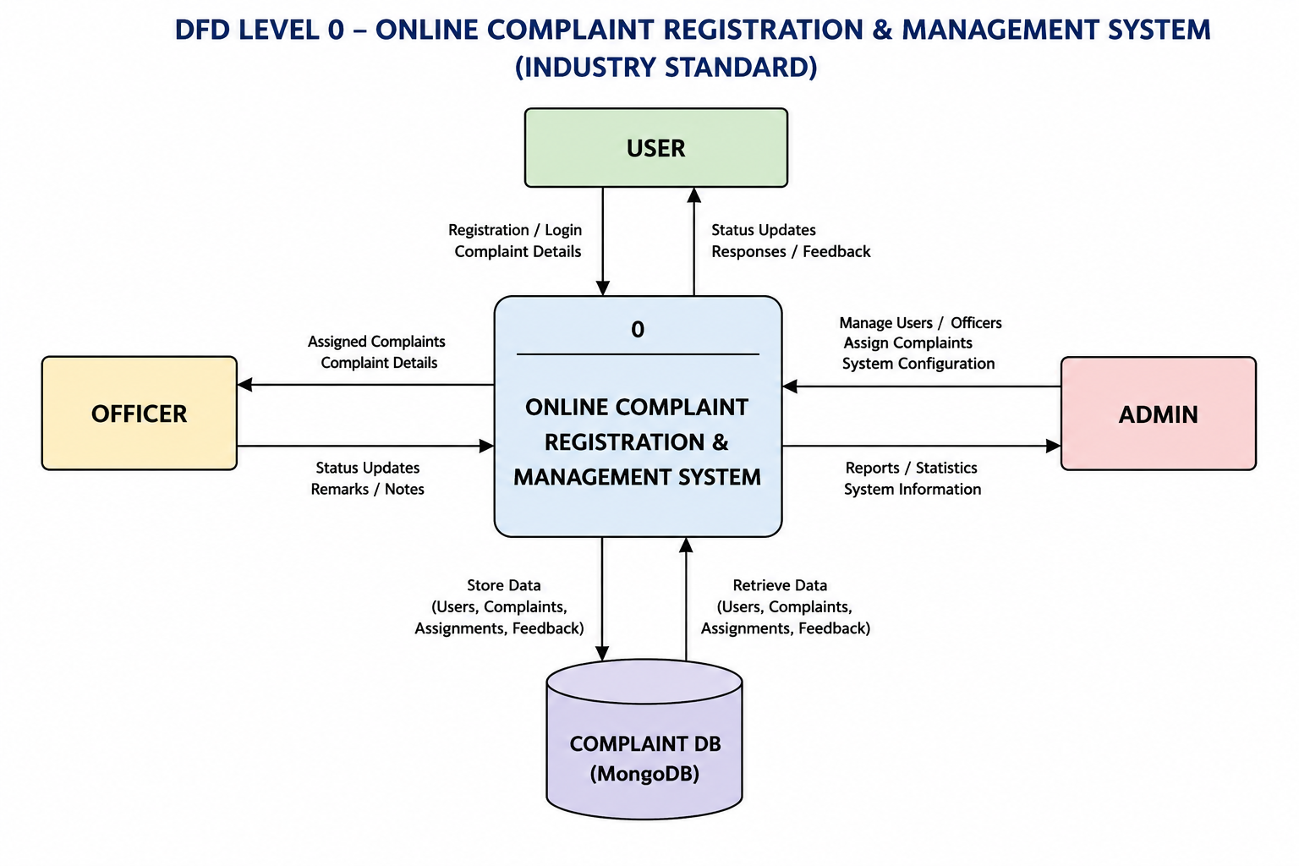
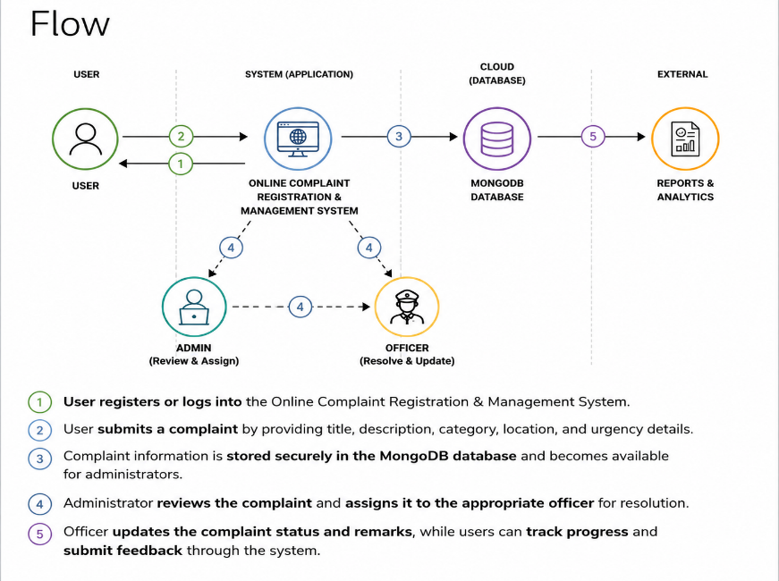
User Stories

User Type | Functional Requirement (Epic) | User Story Number | User Story / Task | Acceptance Criteria | Priority | Release
User | Registration | USN-1 | As a user, I can register using name, email, password and phone number. | User account created successfully. | High | Sprint-1
User | Login | USN-2 | As a user, I can login using email and password. | User can access dashboard. | High | Sprint-1
User | Lodge Complaint | USN-3 | As a user, I can submit a complaint with title, description and category. | Complaint stored in database. | High | Sprint-1
User | Track Complaint | USN-4 | As a user, I can view complaint status. | Current complaint status displayed. | High | Sprint-1
User | Feedback | USN-5 | As a user, I can submit feedback after complaint resolution. | Feedback saved successfully. | Medium | Sprint-2
Officer | Login | USN-6 | As an officer, I can login to manage complaints. | Officer dashboard accessible. | High | Sprint-1
Officer | Complaint Management | USN-7 | As an officer, I can update complaint status. | Status updated successfully. | High | Sprint-2
Admin | Dashboard | USN-8 | As an admin, I can view system statistics. | Dashboard displays counts and reports. | High | Sprint-2
Admin | Officer Approval | USN-9 | As an admin, I can approve officer accounts. | Approved officers can login. | High | Sprint-2
Admin | Complaint Monitoring | USN-10 | As an admin, I can view all complaints. | All complaints displayed. | High | Sprint-2

